**FRS for Employee Management**

**Version 0.1**

**Revision History**

|  |  |  |  |
| --- | --- | --- | --- |
| Date | Version | Description | Author |
| 2015-08-03 | V0.1 | First Draft Version | Lillian Xu |
| 2015-08-10 | V0.2 | Feedback from HDaya:  a) No of years Worked, the format should be <X> Years <X> Months. Age only need to display the integration.  b) List should display Location  c) For certificate, the certificate type is needed: Passport, ID Card, Others  d) under the contact No, added Emergency Contact No(Optional) | Lillian Xu |
| 2015-09-07 | V0.3 | Add Data History requirement | Julia Chen |

Table of Contents

1. Introduction 4

1.1. Overview 4

1.2. Business Overview 4

1.3. Objective 4

2. Functional Description 4

2.1. Search Employee 5

2.1.1. Description 5

2.1.2. Actors 5

2.1.3. Field Definition 6

2.1.4. Business Rules 6

2.1.5. Validation and Message 6

2.2. New/Edit Employee 6

2.2.1. Description 6

2.2.2. Actors 10

2.2.3. Field Definition 10

2.2.4. Business Rules 11

2.2.5. Validation and Message 11

2.3. New/Edit Certificate Detail 12

2.3.1. Description 12

2.3.2. Actors 13

2.3.3. Field Definition 13

2.3.4. Business Rules 13

2.3.5. Validation and Message 13

2.4. New/Edit Family Detail 14

2.4.1. Description 14

2.4.2. Actors 15

2.4.3. Field Definition 15

2.4.4. Business Rules 15

2.4.5. Validation and Message 15

2.5. New/Edit Prior Work History 16

2.5.1. Description 16

2.5.2. Actors 16

2.5.3. Field Definition 17

2.5.4. Business Rules 17

2.5.5. Validation and Message 17

2.6. New/Edit Leave 17

2.6.1. Description 17

2.6.2. Actors 18

2.6.3. Field Definition 18

2.6.4. Business Rules 19

2.6.5. Validation and Message 19

2.7. New/Edit Salary 19

2.7.1. Description 19

2.7.2. Actors 20

2.7.3. Field Definition 20

2.7.4. Business Rules 21

2.7.5. Validation and Message 21

2.7.6. Notes 21

2.8. Delete Employee 21

2.8.1. Description 21

2.8.2. Actors 22

2.8.3. Field Definition 22

2.8.4. Business Rules 22

2.8.5. Validation and Messages 22

1. Introduction
   1. Overview

This document is about the logic of Employee Management, it’s used to manage the Employee Information.

* 1. Business Overview

It is to store and access the database consisting of employee’s personal details and the database can be shared with the concerned department to complete joining formalities. We can also store and access the database consisting of employee details.

Employee information Module keeps the record of all the details pertaining to employees. The personal information about employees will be used to comply with VISA and other laws, to administer benefits, to operate our businesses.

* 1. Objective

1. To improve and enhance the “Employee Information” currently being maintained via Excel
2. To make it available in server for Report extraction.
3. Functional Description

New modules named as Employee Management will be under Management section (Management-> Employee Management), it will only be accessed by people who have the role permission. Once user clicked the Employee Management, below page will be displayed.

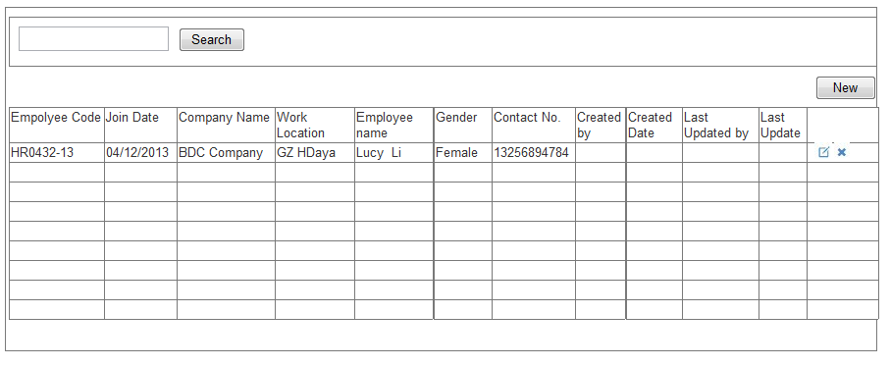

***Picture 2.1.1 Page for Employee Management List***

It includes below functions:

* **Search:** Input search conditions and Click button “Search”.
* **New:** User can click ‘New’ button to new an Employee.
* **Edit:** If user wants to edit the Employee, then click button “Edit”.
* **Delete:** User can click ‘Delete’ to delete the Employee

Detail logics of above functions will be described in detail in below.

* 1. Search Employee
     1. Description

Actor queries Employee information.

* + 1. Actors

Users who have “View” permissions for this module, such as HR Manager.

* + 1. Field Definition

1. **Search:** textbox, Default as Blank, User can search by Employee Code, Employee Name and Status.
2. **Employee List:** It will display with column Employee Code, Join Date, Company Name, Work Location, Employee Name, Gender, Contact No., Created By, Created Date, Last Updated By, and Last Update.
   * 1. Business Rules
3. Default will display all the data belong to current login branch by last update by Descending.
4. All others will follow the Common UI, such as ‘X’, ‘Enter’ in the keyboard
5. All the columns should support sort function.
   * 1. Validation and Message

N/A

* 1. New/Edit Employee
     1. Description

If user wants to create new Employee, then Clicking ‘New’ Button; If user wants to edit Employee, then click the ‘Edit’ button for the item; The layout for Create and Edit Employee are as Below:

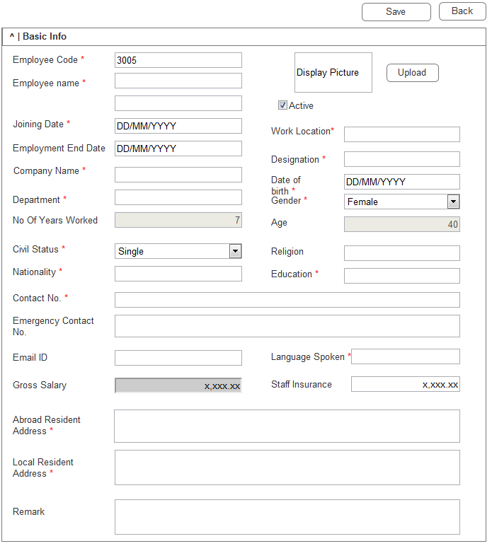

***Picture 2.2.1 Page for New Employee***



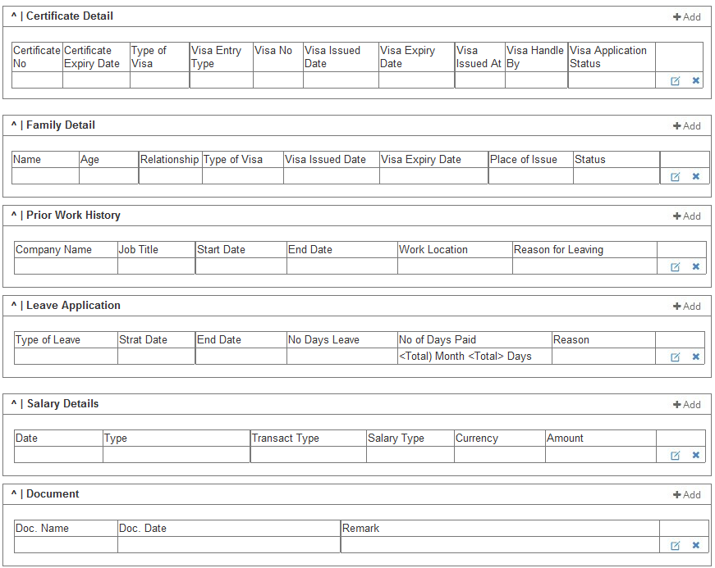

***Picture 2.2.2 Page for Edit Employee***

It includes below functions:

* **Save:** after use update the information, user can click button ‘Save’ to save the data
* **Previous:** follow the UI Standard.
* **Next:** follow the UI Standard.
* **Back:** follow the UI Standard.

Logics for these functions please refer to below items.

* + 1. Actors

Users who have “Edit/New” permission for this module, such as HR Manager.

* + 1. Field Definition

1. **Employee Code:** Textbox, Mandatory, Unique in branch, the value will be configured from Auto No Configuration. If it’s configured from Auto No Configuration, it will be default from Auto No, if it’s not configured from Auto No Configuration, Default will be Blank, max length is 50, Editable.
2. **Employee name:** Textbox, Mandatory, default is blank; it will be included First Name and Last Name. Max length for each is 100.
3. **Picture:** User can upload the picture and display it. The max size is 1M. Optional.
4. **Active:** Checkbox, default is ticked, ticked means active, unticked means inactive.
5. **Joining Date:** Textbox, Date, Mandatory, Default is Current System Date; format is DD/MM/YYYY.
6. **Employment End Date:** Textbox, Date, Optional, Default is blank; format is DD/MM/YYYY.
7. **Company Name:** Textbox, Mandatory, Default is blank, Max Length is 100, User can input data or can select from dropdown list, the data for dropdown list will come from previously saved data. Same as Remitter under LS Payment Module.
8. **Work Location:** Textbox, Mandatory, default is blank, Max length is 50.
9. **Department:** Textbox, Mandatory, Default is blank, Max Length is 20, User can input data or can select from dropdown list, the data for dropdown list will come from previously saved data. Same as Remitter under LS Payment Module.
10. **Designation:** Textbox, Mandatory, Default is blank, Max Length is 50, User can input data or can select from dropdown list, the data for dropdown list will come from previously saved data. Same as Remitter under LS Payment Module.
11. **Gender:** Dropdown, Mandatory, default is Female, and the value for this dropdown is ‘Male, Female’**.**
12. **Date of birth****:** Textbox, Date, Mandatory, Default is blank; format is DD/MM/YYYY.
13. **Age:** Textbox, Read-only, auto calculated based on the ‘Date of birth’ to the current system date, it will be dynamic calculated once user opens this page. And no need to save it into database. Format is xx.
14. **No Of Years Worked:** Textbox, Read-only, auto calculated based on the ‘Joining Date’ to the current system date, it will be dynamic calculated once user opens this page. And no need to save it into database. The format will be <X> Yearly <X> Months.
15. **Civil Status:** Dropdown, Mandatory, default is blank, and the value for this dropdown is ‘Single, Married’
16. **Religion:** Textbox, Optional, Default is blank, Max Length is 50, User can input data or can select from dropdown list, the data for dropdown list will come from previously saved data. Same as Remitter under LS Payment Module.
17. **Nationality:** Textbox, Mandatory, Default is blank, Max Length is 20, User can input data or can select from dropdown list, the data for dropdown list will come from previously saved data. Same as Remitter under LS Payment Module.
18. **Education:** Textbox, Mandatory, Default is blank, Max Length is 555.
19. **Contact No. :** Textbox, Mandatory, Default is blank, Max Length is 100.
20. **Emergency Contact No. :** Textbox, Optional, Default is blank, Max Length is 200.
21. **E-mail ID:** Textbox, Optional, Default is blank, Max Length is 100.
22. **Language Spoken:** Textbox, Mandatory, Default is blank, Max Length is 100.
23. **Gross Salary:** Textbox, ReadOnly, Default is blank, it will be auto calculated based on the detail of ‘Salary section’, and the formula is (Salary + Sum of <Basic>Type <ADD> Transact Type – Sum of <Basic> type <LESS> Transect Type)
24. **Staff Insurance:** Textbox, Mandatory, Digital. Max Length is 12(Including the .), format will be x,xxx.xx for two decimal.
25. **Abroad Resident Address:** Textarea, Mandatory, default is blank, Max length is 255.
26. **Local Resident Address:** Textarea, Mandatory, default is blank, Max length is 255.
27. **Remark:** Textarea, Mandatory, default is blank, Max length is 255.
    * 1. Business Rules
28. The Employee Management module is controlled by Branch Level.
29. Once the input data pass the validation, then this Employee Information will be saved successfully, for the validations, please refer to 2.2.5 Validation and Message
    * 1. Validation and Message

|  |  |  |
| --- | --- | --- |
| **S No.** | **Validations** | **Alert Messages** |
|  | All mandatory Fields should be filled | ** field is required! |

***Table 2.2.1 Validation for Employee***

* 1. New/Edit Certificate Detail
     1. Description

If user wants to create new Certificate Detail, then Clicking ‘New’ Button; If user wants to edit Certificate Detail, then click the ‘Edit’ button for the item; The layout for Create and Edit Certificate Detail are as Below:

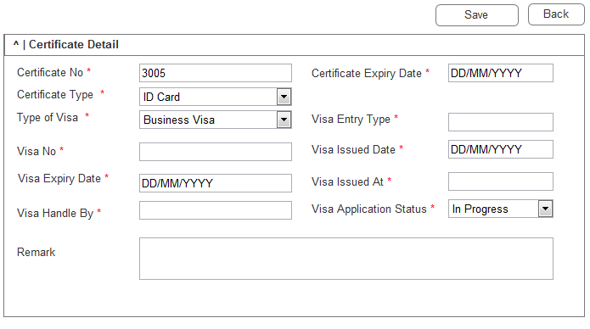

***Picture 2.3.1 Page for New/Edit Certificate Detail***

It includes below functions:

* **Save:** after use update the information, user can click button ‘Save’ to save the data
* **Previous:** follow the UI Standard.

Logics for these functions please refer to below items.

* + 1. Actors

Users who have “Edit/New” permission for this module, such as HR Manager.

* + 1. Field Definition

1. **Certificate No:** Textbox, Mandatory, Default is blank, Max Length is 50.
2. **Certificate Expiry Date:** Textbox, Date, Mandatory, Default is blank; format is DD/MM/YYYY.
3. **Certificate Type:** Dropdown, Mandatory, Default is ‘ID Card’, and the value for this dropdown is ‘ID Card, Passport’.
4. **Type of Visa:** Dropdown, Mandatory, default is blank, and the value for this dropdown is ‘Business Visa, Tourist Visa, Resident Visa, Dependent Visa’
5. **Visa Entry Type:** Textbox, Mandatory, Default is blank, Max Length is 20, User can input data or can select from dropdown list, the data for dropdown list will come from previously saved data. Same as Remitter under LS Payment Module. Sample: one / two / multiple
6. **Visa No:** Textbox, Mandatory, Default is blank, Max Length is 50.
7. **Visa Issued Date:** Textbox, Date, Mandatory, Default is blank; format is DD/MM/YYYY.
8. **Visa Expiry Date:** Textbox, Date, Mandatory, Default is blank; format is DD/MM/YYYY.
9. **Visa Issued At:** Textbox, Mandatory, Default is blank, Max Length is 50, User can input data or can select from dropdown list, the data for dropdown list will come from previously saved data. Same as Remitter under LS Payment Module.
10. **Visa Handle By:** Textbox, Mandatory, Default is blank, Max Length is 20, User can input data or can select from dropdown list, the data for dropdown list will come from previously saved data. Same as Remitter under LS Payment Module. Sample:HK Branch / GZ Branch / FJ Branch / YW Branch / SZ Branch
11. **Visa Application Status** Dropdown, Mandatory, default is blank, and the value for this dropdown is ‘In Progress, Canceled, Hold, Complete, Pending’
12. **Remark’s:** Textarea, Mandatory, default is blank, Max length is 255.
    * 1. Business Rules
13. Once the input data pass the validation, then this certificate will be saved successfully, for the validations, please refer to 2.3.5 Validation and Message
    * 1. Validation and Message

|  |  |  |
| --- | --- | --- |
| **S No.** | **Validations** | **Alert Messages** |
|  | All mandatory Fields should be filled | ** field is required! |

***Table 2.3.1 Validation for Certificate Detail***

* 1. New/Edit Family Detail
     1. Description

If user wants to create new Family Detail, then Clicking ‘New’ Button; If user wants to edit Family Detail, then click the ‘Edit’ button for the item; The layout for Create and Edit Family Detail are as Below:

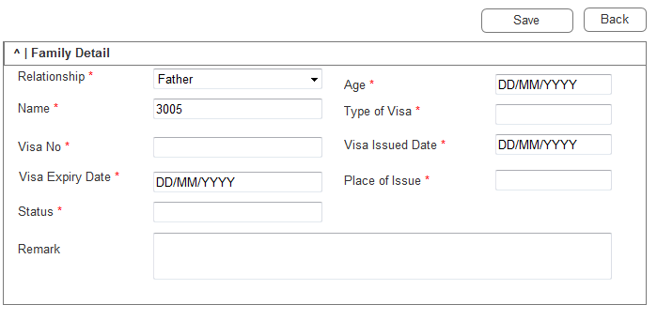

***Picture 2.4.1 Page for New/Edit Family***

It includes below functions:

* **Save:** after use update the information, user can click button ‘Save’ to save the data
* **Previous:** follow the UI Standard.

Logics for these functions please refer to below items.

* + 1. Actors

Users who have “Edit/New” permission for this module, such as HR Manager.

* + 1. Field Definition

1. **Relationship:** Dropdown, Mandatory, default is blank, and the value for this dropdown is ‘Father, Mother, Siblings, Spouse, Child’
2. **Name:** Textbox, Mandatory, Default is blank, Max Length is 100.
3. **Age:** Textbox, Number, Mandatory, Default is blank; format is xx, max length is 2.
4. **Type of Visa:** Textbox, Mandatory, Default is blank, Max Length is 20, User can input data or can select from dropdown list, the data for dropdown list will come from previously saved data. Same as Remitter under LS Payment Module.
5. **Visa No:** Textbox, Mandatory, Default is blank, Max Length is 50.
6. **Visa Issued Date:** Textbox, Date, Mandatory, Default is blank; format is DD/MM/YYYY.
7. **Visa Expiry Date:** Textbox, Date, Mandatory, Default is blank; format is DD/MM/YYYY.
8. **Place of Issue:** Textbox, Mandatory, Default is blank, Max Length is 50, User can input data or can select from dropdown list, the data for dropdown list will come from previously saved data. Same as Remitter under LS Payment Module.
9. **Status:** Dropdown, Mandatory, default is Active, and the value for this dropdown is ‘Active, Inactive’
10. **Remark’s:** Textarea, Mandatory, default is blank, Max length is 255.
    * 1. Business Rules
11. Once the input data pass the validation, then this import loan will be saved successfully, for the validations, please refer to 2.4.5 Validation and Message
    * 1. Validation and Message

|  |  |  |
| --- | --- | --- |
| **S No.** | **Validations** | **Alert Messages** |
|  | All mandatory Fields should be filled | ** field is required! |

***Table 2.4.1 Validation for Family***

* 1. New/Edit Prior Work History
     1. Description

If user wants to create new Prior Work History, then Clicking ‘New’ Button; If user wants to edit Prior Work History, then click the ‘Edit’ button for the item; The layout for Create and Edit Prior Work History are as Below:

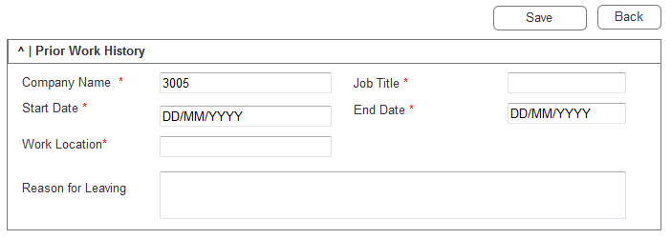

***Picture 2.5.1 Page for New Prior work History***

It includes below functions:

* **Save:** after use update the information, user can click button ‘Save’ to save the data
* **Previous:** follow the UI Standard.

Logics for these functions please refer to below items.

* + 1. Actors

Users who have “Edit/New” permission for this module, such as HR Manager.

* + 1. Field Definition

1. **Company Name:** Textbox, Mandatory, Default is blank, Max Length is 100, User can input data or can select from dropdown list, the data for dropdown list will come from previously saved data. Same as Remitter under LS Payment Module.
2. **Job Title:** Textbox, Mandatory, Default is blank, Max Length is 100.
3. **Start Date:** Textbox, Date, Mandatory, Default is blank; format is DD/MM/YYYY.
4. **End Date:** Textbox, Date, Mandatory, Default is blank; format is DD/MM/YYYY.
5. **Work Location:** Textbox, Mandatory, default is blank, Max length is 50.
6. **Reasons for Leaving:** Textarea, Mandatory, default is blank, Max length is 255.
   * 1. Business Rules
7. Once the input data pass the validation, then this import loan will be saved successfully, for the validations, please refer to 2.5.5 Validation and Message
   * 1. Validation and Message

|  |  |  |
| --- | --- | --- |
| **S No.** | **Validations** | **Alert Messages** |
|  | All mandatory Fields should be filled | ** field is required! |

***Table 2.5.1 Validation for Prior work History***

* 1. New/Edit Leave
     1. Description

If user wants to create new Leave, then Clicking ‘New’ Button; If user wants to edit Leave Detail, then click the ‘Edit’ button for the item; The layout for Create and Edit Leave Detail are as Below:

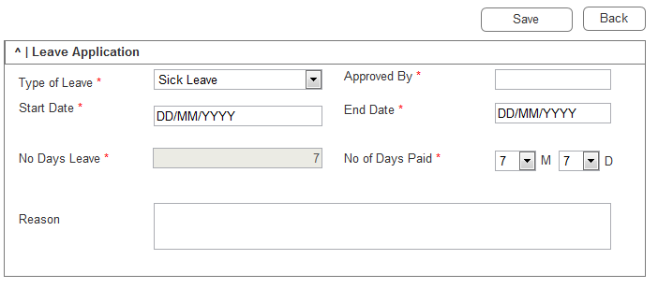

***Picture 2.6.1 Page for New Leave***

It includes below functions:

* **Save:** after use update the information, user can click button ‘Save’ to save the data
* **Previous:** follow the UI Standard.

Logics for these functions please refer to below items.

* + 1. Actors

Users who have “Leave” permission for this module, such as HR Manager.

* + 1. Field Definition

1. **Type of Leave:** Dropdown, Mandatory, default is ‘Annual Leave’, and the value for this dropdown is ‘Sick Leave, Annual Leave, Maternity leave, Personal Leave’
2. **Approved By:** Textbox, Mandatory, Default is blank; Max Length is 50. User can input data or can select from dropdown list, the data for dropdown list will come from previously saved data. Same as Remitter under LS Payment Module
3. **Start Date:** Textbox, Date, Mandatory, Default is the current client’s system date; format is DD/MM/YYYY.
4. **End Date:** Textbox, Date, Mandatory, Default is the current client’s system date; format is DD/MM/YYYY.
5. **No Days Leave:** Textbox, Mandatory, Auto Calculate based on Start and End Date+1. No need to consider Holidays and weekends, default is 1. User can edit
6. **No of Days Paid:** Dropdown, Mandatory, Month Drop Down ‘1-12’, Day Drop Down – ‘1-31’, both default is 1.
7. **Reason:** Textarea, Mandatory, default is blank, Max length is 255.
   * 1. Business Rules
8. Once the input data pass the validation, then this import loan will be saved successfully, for the validations, please refer to 2.6.5 Validation and Message
   * 1. Validation and Message

|  |  |  |
| --- | --- | --- |
| **S No.** | **Validations** | **Alert Messages** |
|  | All mandatory Fields should be filled | ** field is required! |

***Table 2.6.1 Validation for Leave***

* 1. New/Edit Salary
     1. Description

If user wants to create new Salary, then Clicking ‘New’ Button; If user wants to edit Salary, then click the ‘Edit’ button for the item; The layout for Create and Edit Salary are as Below:

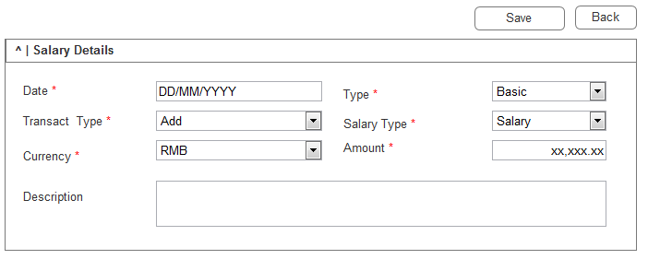

***Picture 2.7.1 Page for New Salary***

It includes below functions:

* **Save:** after use update the information, user can click button ‘Save’ to save the data
* **Previous:** follow the UI Standard.

Logics for these functions please refer to below items.

* + 1. Actors

Users who have “Salary” permission for this module, such as HR Manager.

* + 1. Field Definition

1. **Date:** Textbox, Date, Mandatory, Default is blank; format is DD/MM/YYYY.
2. **Type:** Dropdown, Mandatory, default is blank, and the value for this dropdown is ‘Basic, Compulsory, Monthly’

* Basic – Salary / Increment / Decrement/Allowance
* Compulsory – Insurance / Loan Deduction
* Monthly –Late fee / leave salary

1. **Transact Type:** Dropdown, Mandatory, default is blank, and the value for this dropdown is ‘Add, Less’
2. **Salary Type:** Dropdown, Mandatory, default is blank, and the value for this dropdown is ‘Salary, Increment, Bonus, Deduction, Allowance, Staff Insurance, Leave Salary, Late Fee, Mandatory Provident Fund, Maternity Leave, Others’, this will be filtered based on the Type.
3. **Currency:** Dropdown, Mandatory, default is blank, and the data from the dropdown list will be coming from the Currency Master.
4. **Amount:** Textbox, Mandatory, default is blank, Digital. Max Length is 12(Including the .), format will be x,xxx.xx for two decimal.
5. **Description:** Textarea, Mandatory, default is blank, Max length is 255.
   * 1. Business Rules
6. Once the input data pass the validation, then this import loan will be saved successfully, for the validations, please refer to 2.2.5 Validation and Message
   * 1. Validation and Message

|  |  |  |
| --- | --- | --- |
| **S No.** | **Validations** | **Alert Messages** |
|  | All mandatory Fields should be filled | ** field is required! |

***Table 2.7.1 Validation for Salary***

* + 1. Notes

This will be designed in new tab like ‘Add/Less’ under Sales Order module. And this tab will be controlled by user permission

* 1. Delete Employee
     1. Description

If user wants to delete the Employee, then user can click ‘Delete’ button to delete this Employee.

* + 1. Actors

Users who have “Delete” permission for this module, such as HR Manager.

* + 1. Field Definition

N/A

* + 1. Business Rules

1. Only inactive employee can be deleted.
   * 1. Validation and Messages

|  |  |  |
| --- | --- | --- |
| **S No.** | **Validations** | **Alert Messages** |
|  | Employee should be in inactive status | Employee is not inactive status! |

***Table 2.7.1 Validation for delete Employee***

* 1. Data History
     1. Description

It will record all the data update information.

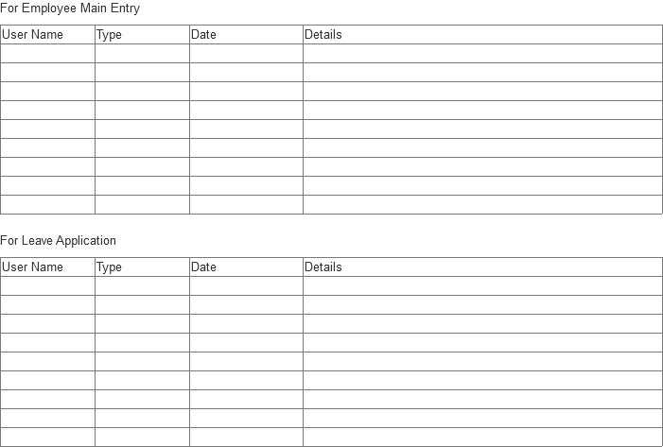

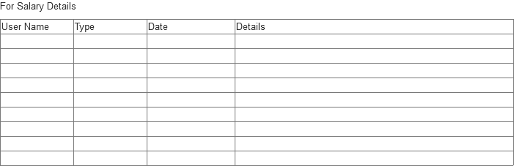

* + 1. Actors

There are 3 tables which separately record log details in Main tab, Leave Application tab and Salary Details tab. Users who have “View” permission for this module, can view Data History of Main tab; Users who have permission for Leave Application tab, can view Data History of Leave Application tab; Users who have permission for Salary Details tab, can view Data History of Salary Details tab.

* + 1. Field Definition

1. The log details should include the change for field level. And it will only be displayed once ‘Show’ is clicked.
2. **User Name:** User’s login name. who operated this data
3. **Type:** For Employee Management (Basic Information) level, if it’s newly created, the type will be ‘Create’, for update, the type will be ‘Update’; For Certificate Detail, Family Detail, Prior Work History, Leave Application, Salary Details, Document level, if the item is newly added, the type will be ‘Add’, for update items, the type will be ‘Update’, for delete items, the type will be ‘Delete’.
4. **Date:** The client PC’s operation date.
5. **Details:** for create/add, it will record all the fields with created data, the format will be “<Which section>: <Field Name>: <Value>;<Field Name1>:<Value1>”, such as “Basic Info: Employee First Name: Hdaya”; for update, it will record all the fields with Updated data, the format will be “<Which section>: <Field Name>:From <Value> to <Value>,<Field Name1>:From <Value> to <Value1>”, such as” Certificate Detail: Certificate Type: From ID Card To Others, Visa Issue Date: From 01/09/2015 To 06/09/2015”; for delete items, it will record all the fields with current data, the format will be “<Which section>: <Field Name>: <Value>;<Field Name1>:<Value1>”.